**Welsh Contemplatives Speak From Their Silence**

On the feast of St. David, the Cistercian nuns of Whitland talk of the beauty of their life and offer strategies from monastery life for living well during the pandemic.

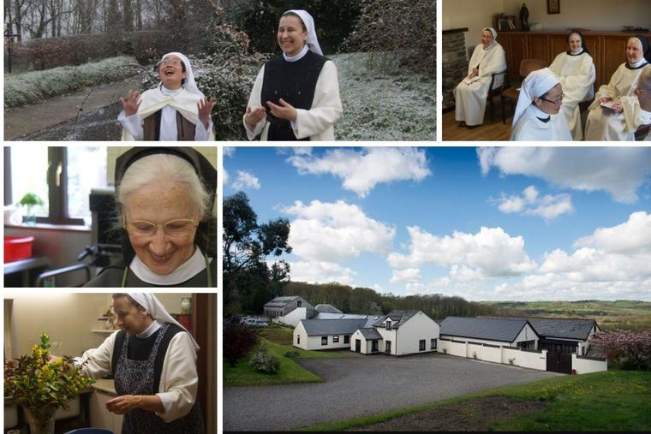Contemplative life at Holy Cross Abbey is rooted in prayer, reading the word of God and manual work. Joy punctuates their lives. (photo: Courtesy of Holy Cross Abbey via hcawhitland.co.uk)

[K.V. Turley](https://www.ncregister.com/author/k-v-turley) [Features](https://www.ncregister.com/section/features)March 1, 2021

In January 1991, a community of Cistercian nuns of the strict observance purchased the Waungron Farm Motel at Whitland in Wales just across the valley from the old Whitland Abbey founded in 1151 by Bernard, the first Norman bishop of St. David’s (1115-48) with monks from Clairvaux in France.

In 2006 Mother Christine Wood was elected abbess of [Holy Cross Abbey](https://www.hcawhitland.co.uk/who-we-are/the-community). Gradually in the ensuing years, the farm motel has been transformed into a monastery. The monastic church was dedicated in 2011.

Just ahead of the feast day of St. David, a sixth-century Welsh bishop who is the patron saint of Wales, on March 1, the community at Whitland spoke to the Register about their vocation and life.

*What, in essence, is the contemplative vocation?*

The contemplative vocation faces two ways: We are earthbound, but our eyes on God. Through our reading and prayer, we live a life of the Spirit. We seek God, and God finds us.

*And what is the essence of the Cistercian vocation in particular?*

The contemplative Cistercian vocation is to live under the Rule of St. Benedict in obedience to an abbot or abbess. It has three pillars. We live a life of prayer, daily *lectio divina* (reading the word of God) and manual work. Traditionally, Cistercian manual work was farming, but many monasteries have moved into other areas to earn a living. Our monastery makes and sells altar breads.

We live in community and in solitude; we pray together and have our own personal private prayer. We live simply and value silence that we may concentrate on God. We only go outside the enclosure when necessary, e.g., for the health care; we do not watch television and use the internet sparingly.

Our vows are of obedience, stability and conversion. Stability means to remain in one monastery; conversion encompasses poverty, chastity and a lifelong effort to conquer our weaknesses and live fully the Gospel values. Ours is a hidden life, “in assiduous prayer and joyful penitence” (“Constitutions & Statutes of the Cistercian Nuns of the Strict Observance”).

*How has the current pandemic impacted the life of the community?*

Like everyone else, we have had difficulties during the pandemic, which is a shocking event and unprecedented in all our lives. We have had to come to terms with the closure of the churches and closed our guesthouse. Our income dried up, as the altar bread orders stopped. We had to explain to two of our part-time employees that we no longer had any work for them. We started daily Exposition; we pray at the end of vespers Pope Francis’ “[Prayer to Mary](https://www.hcawhitland.co.uk/storage/app/media/pope-francis-prayer-coronavirus.pdf) During Coronavirus Pandemic.”

Life within the community, in many ways, continues normally; but there are differences. We have experienced the absence of Mass, which is hard. But we have been nourished by the Body of Christ each day at a Eucharistic service led by the abbess or prioress. Each sister has her own worries for the community, their family, friends, and for all people of the world. We receive more prayer requests from people who are in distress. Our faith is tested, but God’s love is ever present.

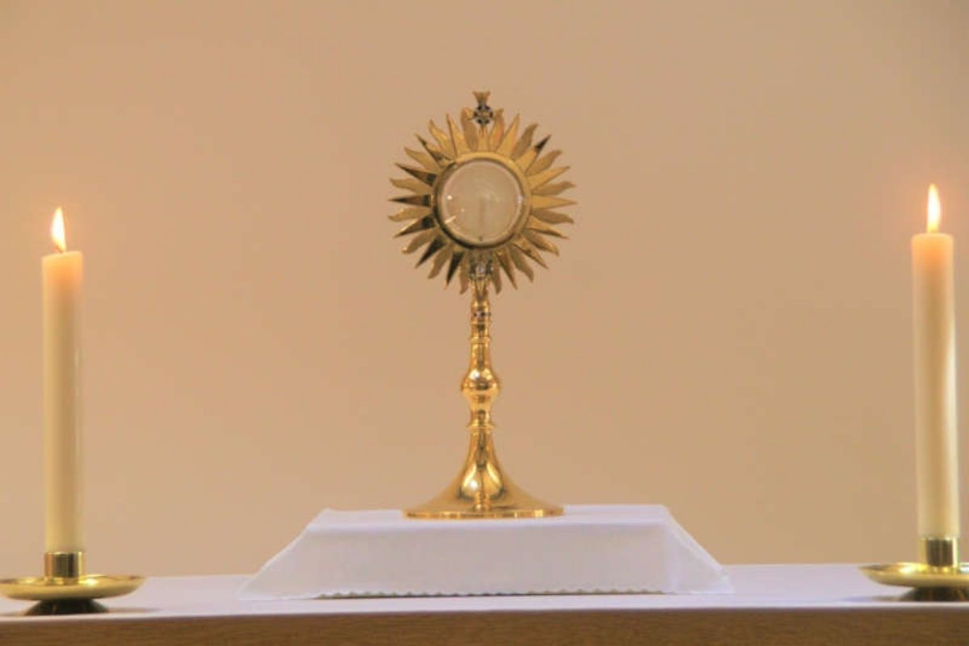The Cistercian nuns at Holy Cross Abbey pray at the end of vespers Pope Francis’ ‘Prayer to Mary During Coronavirus Pandemic.’

*You live lives enclosed, silent and centered on prayer. What would you say to so many Catholics forced to live in continuing isolation due to the pandemic?*

We are social beings, and the lockdowns are not a normal way of living. It has been imposed for the good of all, but without any preparation time. When we come to the monastery in response to a call from God, we enter a six-year formation program. One of the major difficulties that everyone encounters then is the separation from loved ones and mixing with the same sisters day in and day out. The lack of distractions through social interactions and activities means that our thoughts trouble us more; we have to learn about ourselves, our true selves, to cope and remain focused on why we came to the monastery: to seek God and to do his will.

We, therefore, recognize the difficulties of living in enforced isolation due to the pandemic. Some coping strategies from the monastery include having a structure to your day. Build in a period of quiet time; link into nature: if you cannot go outdoors, then look out and see the natural world. Choose a time to read and pray, and keep a journal of your reflections from spiritual reading; this helps to deepen your relationship with God. Be aware of what you are doing and why, so that you can make choices about how to use your time; be open to the unexpected. Living in community, we learn to be gentle with ourselves and others: If we have upset another, then we need to seek forgiveness and apologize. A smile is always welcome, a simple gesture of regard. Laughter is a “feel-good’” and helps to reduce tension and stress.

We are aware of our physical health needs, and, during the pandemic, there is much more awareness of mental-health issues, but little has been made of spiritual well-being. There are so many needs to put before the Lord in prayer. We pray for those who are ill; all who have died and those who are mourning; for all whose lives have been disrupted though economic hardship, social, spiritual and educational deprivation, and loneliness.

Through prayer we really are all in this together, even though our experiences are unique. This is an opportunity to reexamine our lives and see where God is.

*Contemplatives experience freedom in their lives, but not as the world offers. Could you say something about that?*

One of the freedoms of living a monastic life is that the pressures of consumerism no longer apply. We wear a traditional habit, so the latest fashion and “must-haves” are irrelevant. We use our money for the community’s needs and for almsgiving.

Putting down our roots in the monastery, we become more aware of nature: the light and colors, the changes of the seasons, the stars at night, the rhythms of life which have nothing to do with human effort. Contemplation gives a wider outlook as we ponder God’s love for all creation.

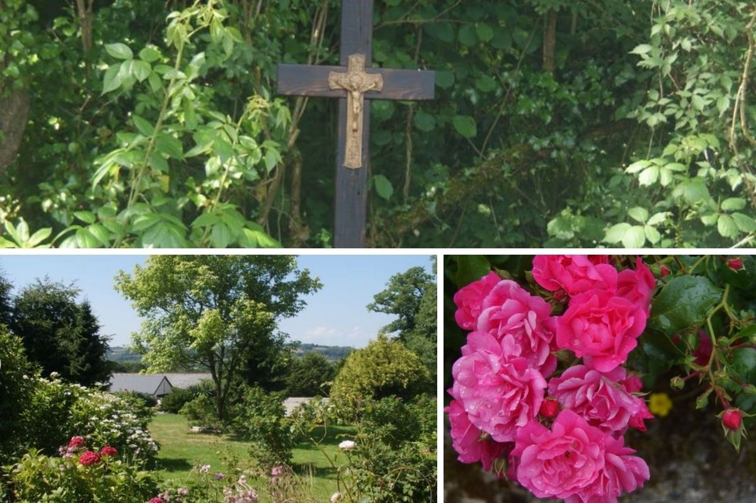The natural beauty of the Welsh countryside supports the monastic life: ‘Contemplation gives a wider outlook as we ponder God’s love for all creation.’

*Holy Cross Abbey is one of the few monasteries left in Wales today. What do you see as your link to the country?*

Wales has a strong, ancient Christian heritage. Visitors to Wales notice the large number of chapels and the frequency of place names taken from the Bible. Since the sixth century, Caldey Island has been inhabited by monastic communities and is currently the home of our Cistercian brothers. The Diocese of Menevia, the oldest diocese in Wales, founded by St. David (500-589), links us to the monks of old. Whitland is where Hywel Dda (Hywel the Good, who died in 950) presented his law; and across the valley, there are the ruins of the medieval Whitland Abbey (1151-1539) founded by monks from St. Bernard’s monastery in Clairvaux, France.

We are relative newcomers to Wales. This year we celebrate 30 years in Whitland. The sisters were praying to St. Joseph for a new home, and Bishop Daniel Mullins was praying to St. Joseph for a Eucharistic presence to be established between Haverfordwest and Carmarthen.

*Does your monastery have a particular mission to the Welsh?*

Our constitutions speak of our apostolate: “It is the contemplative life itself that is their way of participating in the mission of Christ and his Church and being part of the local church.”

In practice, our mission is to live our Christian monastic heritage fully so as to be a sign of God’s love. We offer a place of prayer, peace and quiet for all who visit and the opportunity to join in the Divine Office. We are “lovers of the place” and take our stewardship of the land seriously.

Before the pandemic, we would also welcome groups of schoolchildren to visit; we would show them how altar breads are made; talk about how we live and why. They would then come to church for prayer. We would chant the Psalms and ask the children to lead us in a hymn or prayer they had prepared.

*Does your sense of the monastic past influence your current sense of mission*?

We see ourselves as continuing the monastic tradition. Our lives are lived differently from the Cistercian monks buried across the valley, but the pattern of our day would be recognizable to them.

*How hard is it to attract vocations?*

The Cistercian vocation is a rare vocation these days. The idea of giving up everything for God requires a conviction that you have no other option than to answer God’s call, and it is dependent on God’s grace for it to come to fruition.

*Where do those who discern their vocations here come from, and what attracts them?*

Our vocations often come through our website. These are women who are actively seeking their vocation. They are looking for an authentic life of prayer.

*What is the greatest joy of your vocation?*

We get up early for vigils as the day is dawning, and there is a great joy. We do not have to go anywhere: It [the joy] is here. The joy is in recognizing afresh a beautiful gift; to find it in reading Holy Scripture, the Cistercian Fathers, or by looking out of the window or going for a walk, acknowledging the gift: It is not of our making, but has been given freely. We see this joy in our older sisters: their peace and patience, a wholeness and presence. Their joy is in passing on a tradition and being content in it.

It is said of St. David that the last words he preached the Sunday before his death were: “Be joyful, keep the faith, and do the little things that you have heard and seen me do.” The saying *Gwenewch y pethau bychain mewn bywyd* [“Do the little things in life”] is still used today in Wales.

This is a fulfilled life: We journey as pilgrims to the Father’s house despite our failures and weaknesses.

* *Keywords:*
* [k.v. turley](https://www.ncregister.com/tag/k-v-turley)
* [contemplative life](https://www.ncregister.com/tag/contemplative-life)
* [cisterian nuns](https://www.ncregister.com/tag/cisterian-nuns)
* [st. david](https://www.ncregister.com/tag/st-david)
* [feast of st. david](https://www.ncregister.com/tag/feast-of-st-david)
* [cistercian nuns of whitland](https://www.ncregister.com/tag/cistercian-nuns-of-whitland)
* [welsh contemplatives](https://www.ncregister.com/tag/welsh-contemplatives)

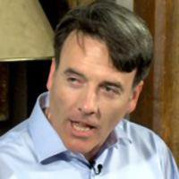

[**K.V. Turley**](https://www.ncregister.com/author/k-v-turley) K.V. Turley is the Register’s U.K. correspondent. He writes from London.